**Depiction Of Managing the Data Advanced Secure Based**

**For Predominant Brands**

**PREFACE**

**TABLE OF CONTENTS**

**1. SOFTWARE DEVELOPMENT LIFE CYCLE**

**2. PLATFORM KNOWLEDGE**

**3. DOMAIN KNOWLEDGE**

**4. ABOUT PROJECT**

4.1 ABSTRACT

4.2 SCOPE OF THE PROJECT

4.3 EXISTING SYSTEM

4.3.1 DISADVANTAGES

4.4 PROPOSED SYSTEM

4.4.1 ADVANTAGES

**5. BOTTOM LINE AND FUTURE ENHANCEMENT**

**6. SOFTWARE AND HARDWARE REQUIREMENTS**

**1. SDLC (Software Development Life Cycle)**

The Software Development Life Cycle is a systematic process for building software that ensures the quality and correctness of the software built. SDLC process aims to produce high-quality software which meets customer expectations. The software development should be completed within the pre-defined time frame and cost.

**SDLC Phases**

The entire SDLC process is divided into the following stages:

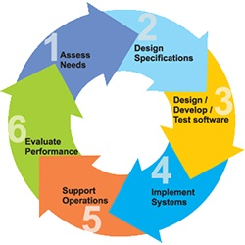

* Phase 1: Requirement gathering and analysis
* Phase 2: Feasibility Study
* Phase 3: Design
* Phase 4: Coding
* Phase 5: Testing
* Phase 6: Installation/Deployment
* Phase 7: Maintenance

**2. PLATFORM KNOWLEDGE**

**Introduction to java**

Java programming language was originally developed by Sun Microsystems which was initiated by James Gosling and released in 1995 as a core component of Sun Microsystems' Java platform. Initially, the language was called “Oak” but it was renamed as “Java” in 1995. The primary motivation of this language was the need for a platform-independent language. Finally, Java is for Internet Programming where C was to System Programming.

**Java architecture**

Java is a high-level Object-oriented programming language. A program written in high level language cannot be run on any machine directly. First, it needs to be translated into that particular machine language. The javac compiler does this thing, it takes java program (.java file containing source code) and translates it into machine code (referred as byte code or .class file). Java Virtual Machine (JVM) is a virtual machine that resides in the real machine (your computer) and the machine language for JVM is byte code. JVM executes the byte code generated by compiler and produce output. JVM is the one that makes java platform independent.

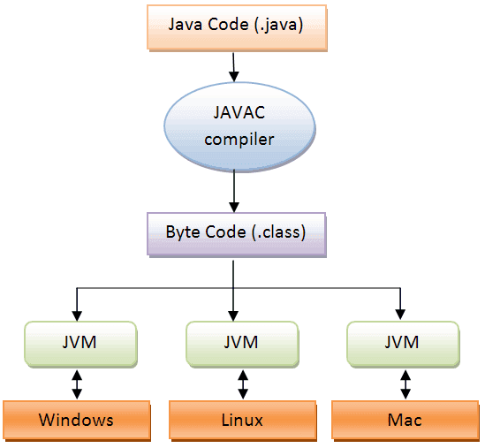

**3. DOMAIN KNOWLEDGE:**

**CYBER SECURITY:**

Cyber security is the practice of defending computers, servers, mobile devices, electronic systems, networks, and data from malicious attacks. It's also known as information technology security or electronic information security

**Advanced Encrypted Algorithm:**

# The AES Encryption algorithm (also known as the Rijndael algorithm) is Advanced Encrypted Algorithm a symmetric block cipher algorithm with a block/chunk size of 128 bits. It converts these individual blocks using keys of 128, 192, and 256 bits. Once it encrypts these blocks, it joins them together to form the ciphertext.Data encryption usually goes on behind the scenes – when we register a password for an online service, that password is stored (or at least it should be) in a salted and hashed format a form of encryption that prevents hackers from being able to simply read our login credentials if they gain access to the website’s database. A combination of regulations and good practice makes it standard for businesses to encrypt any sensitive customer information they store, so in a sense we’re already making use of data encryption. However, for personal security it would be even better to think about data encryption closer to home. When we back up sensitive data, it may be worth encrypting it as well. In general when choosing an encryption service, choose a well-known peer-reviewed encryption algorithm – such as AES or its successor

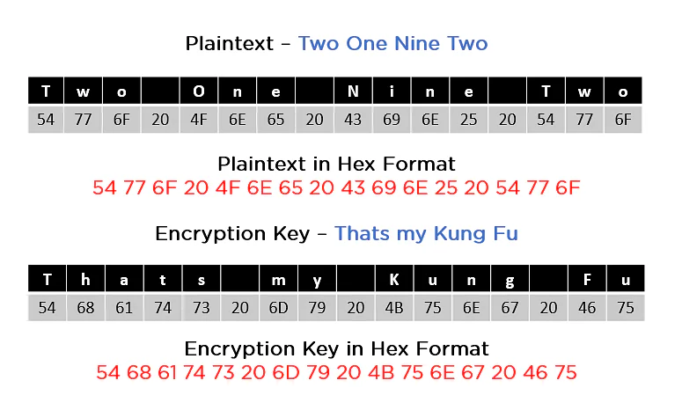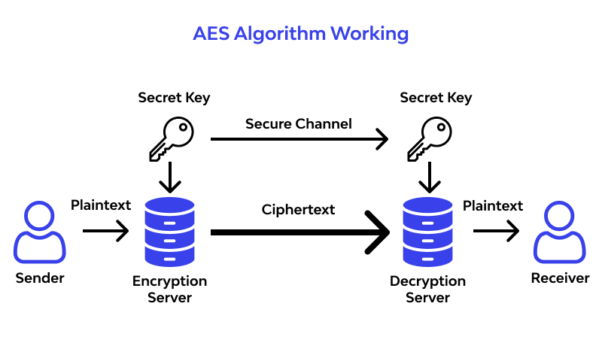

**Depiction Of Managing the Data Advanced Secure Based**

**For Predominant Brands**

**4. ABOUT THE PROJECT**

**4.1 Abstract**

In E-commerce platform on Apparel Industry where There are easy ways that may enable you to promote Brand Products in bulk and find buyers with ease, among the most prominent of which is to take advantage of websites related to buying and selling products online. (AES Algorithm) can be used to establish security on customer payments. Ecommerce is the online exchanging of products and services. In this process, we'll offer services for both B2B and B2C.While in the B2C process of selling the products of our own brand Products directly to a consumer An ecommerce store selling products directly to a consumer at home.In B2B process of buying the products Another Business Products Brands the margin from B2C products calculated through the investments on other Brands products and selling goods from the consumers can be determain the profits application, The investment in the B2B process was based on the wholesale were we investing to buy the products which we have some certain discounts. We have observed payment scams or hacker attempts to access to payment detail data of customers while making payments online. In this project our application act as a dealer or retailer for purchase goods/services from wholesaler or distributor and sells to end customers at marked-up prices with some discounts. Online Retailers play one of the most important role in the business and cater to the end customers helping the supply chain and demand/supply cycles.For need to purchase different variety of goods depending on the customer base and needs to stock them safely before selling. End customers will prefer goods which are in good condition and are fresh. Also customers prefer stores where they can experience or see the product well before buying. Our application has to make sure of the final quality.

**4.2 SCOPE OF THE PROJECT:**

Business-to-business (B2B), also called B-to-B, is a form of transaction of goods and sales between businesses to Business Organisation, such as one involving a manufacturer and wholesaler, or a wholesaler and a retailer. Business-to-business refers to business that is conducted between companies, rather than between a company and individual consumer. In websites allow Business Vendor interested parties to learn about a business's products and services and initiate contact. Online product and supply exchange websites allow businesses to search for products and services and initiate procurement through e-procurement interfaces. Specialized online directories providing information about particular industries, companies and the products and services they provide also facilitate B2B transactions The purpose of the our application it act as both B2B part on one part and B2C on another part in there outside market there are different business organization available on the Clothes Industry they have the competition between sales to sustain on this competition they have to make their brands sales with the high margin status so they have approached different platform for sales where in on board showrooms to promote the brands but if some of products were not get the exacted scale ratio but if it gets the low scale ratio and also not satisfied with the expected margin Business organization face the losses after revolution of this ecommerce the conflicts are reduced little and losses are minimized because if the sales on online for user are attracted through discounts and offers it has been advertised on different platforms to make focus on the unsaled goods still business vender facing the problem because of the ecommerce they expceting pay 30% to 40% commission from the profit to overcome this process we enhanced the new process for business organization for to sale the products and also minimized the losses through promoting the different brands with discounted price which all occur on the single application based application make the some conflicts .

**4.3 Existing Purpose:**

In existing system which has difficulty to obtain the margin in the ecommerce and also retail partners because their own product brand representation priority has been decided by the money they spend on the ecommerce platform so their products branding advertisement has been depend on the payments we have invest so if competitor has ready to any more than brand it will affect the other products because the competitor brands promotions are high when compare to other products it major disadvantage on the ecommerce platform and the review customers are also depended on the product sales its all the problems faced by the business organization brands in B2B.when its came for the payment process identity fraud or identity theft happens when criminals get consumer information by purchasing or hacking the user's account and then use it to carry out their phishing operations. Among the stolen information and data they can make fraud transaction. The rise of the ecommerce business, as well as the increase in payment methods such as cards and online payment solutions, is clearly connected to an increase in fraud

**DISADVANTAGE:**

* Business loss and profit is depends on the advertisement on the ecommerce platform
* The retail partner plans and strategies has been not aware in the large business organization
* Payments methods or the user identification data theft are more increase in the existing models
* The conflicts between the road side sale, showroom sale and ecommerce sale are depends the customer needs and demand but the marketing strategies of other
* Customers may make more demands, from pricing to customization.

**4.4 Proposed System**

In the proposed system our application design framework are built on the base of reducing the conflict in the outside trend of releasing the new product in the fashion cooperation by creating the platform on the ecommerce based on B2B sales and also B2C sales has been implemented on our own application to enhance the sales if one of the brand sale are not good enough means we can handle that loss through the retail partner brand sales in existing there is not available of B2C and B2B where on the same platform our application has been develop on the basis of design format so in the payment process we are using the algorithm to get the information of the user payment cards in the encrypted base and after the key has been provided then only decryption of the user payment information so it makes the high level of security that we can prevent the scam and hacking the accounts

**ADVANTAGE:**

* Our product brands promotion has been provided by our own application
* Reach of the products on customers also high
* Fashion Business Organization can promote the products to the another Fashion Business Organization on their ecommerce platform
* A reverse auction is a process in which sellers bid to sell their goods and services also in application
* Retail Partners and B2B are in the same application so it can enhance the profit and manage the loss also in the same application
* Satisfaction of different kinds of customers also added for up gradation.
* Long term customer relationships and Bigger sales with bigger value
* Lower costs of operation resulting from being able to operate in bulk

**5. BOTTOM LINE AND FUTURE ENHANCEMENT**

There the need of overcome of the loss by the ecommerce platform by the fashion brand organizations .In this design we have followed the B2B and B2C are in same ecommerce platform .The application is developed on the basis of ecommerce based platform and the customer payments information has been protected in the following basis of encryption we have using is AES encryption and decryption. While it can improve customer security satisfaction and extend market reach, it can also expose an organization to significant security risks. Security professionals, we must understand these risks and guide the discussion about acceptance and mitigation of these risks. The newest generation of servers and management tools makes it far easier to add new resources or components without downtime or service interruptions.

**6. HARDWARE AND SOFTWARE REQUIREMENTS**

**Hardware requirements:**

* Processor : Intel (R) Pentium (R)
* Speed : 1.6 GHz and Above
* RAM : 4 GB and Above
* Hard Disk : 120 GB
* Monitor : 15’’ LED SVGA
* Input Devices : Keyboard, Mouse

**Software requirements:**

* Operating system : Windows 7 / 8 / 8.1 / 10
* Coding Language : JAVA / J2EE
* Java Version : jdk 8
* IDE : Eclipse Oxygen
* Database : MySQL v5.1
* Database Tool : HeidiSql v11.0
* Application Server : Apache Tomcat 8.X / 9.X